**Spring REST using Spring Boot 3**

**1.Create a Spring Web Project using Maven**

**SpringLearnApplication.java**

package com.cognizant.spring_learn;

import org.springframework.boot.SpringApplication;

import org.springframework.boot.autoconfigure.SpringBootApplication;

@SpringBootApplication

public class SpringLearnApplication {

public static void main(String[] args) {

SpringApplication.run(SpringLearnApplication.class, args);

}

}

**OUTPUT:**

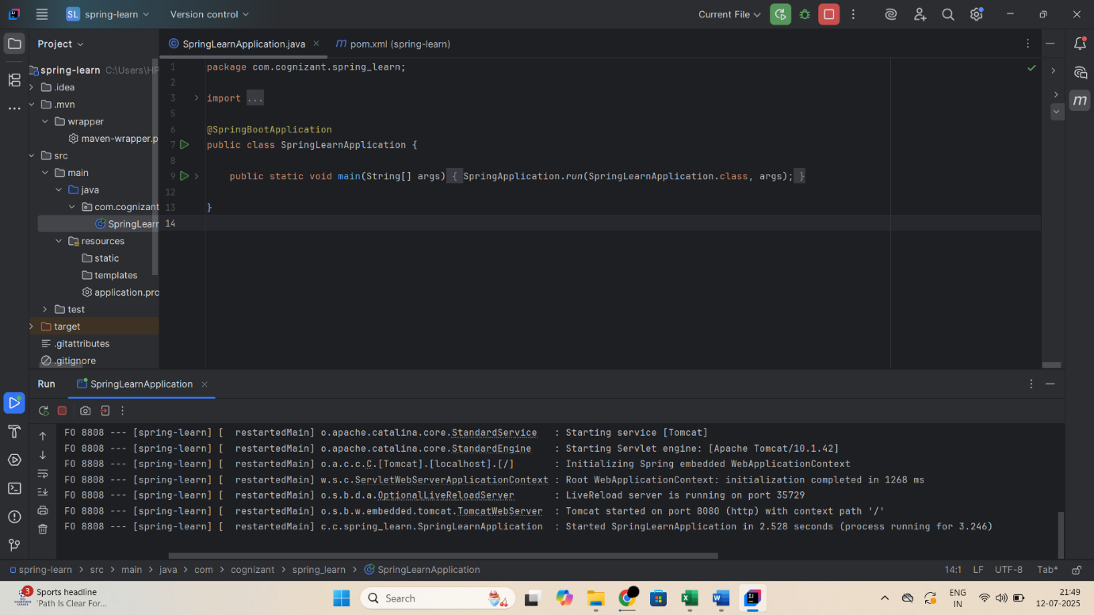

**2.Spring Core – Load Country from Spring Configuration XML**

**Country.java**

package com.cognizant.springlearn;

import org.slf4j.Logger;

import org.slf4j.LoggerFactory;

public class Country {

private static final Logger LOGGER = LoggerFactory.getLogger(Country.class);

private String code;

private String name;

public Country() {

LOGGER.debug("Inside Country Constructor.");

}

public String getCode() {

LOGGER.debug("Getting Country Code: {}", code);

return code;

}

public void setCode(String code) {

LOGGER.debug("Setting Country Code: {}", code);

this.code = code;

}

public String getName() {

LOGGER.debug("Getting Country Name: {}", name);

return name;

}

public void setName(String name) {

LOGGER.debug("Setting Country Name: {}", name);

this.name = name;

}

@Override

public String toString() {

return "Country [code=" + code + ", name=" + name + "]";

}

}

**country.xml**

<?xml version="1.0" encoding="UTF-8"?>

<beans xmlns="http://www.springframework.org/schema/beans"

xmlns:xsi="http://www.w3.org/2001/XMLSchema-instance"

xsi:schemaLocation="http://www.springframework.org/schema/beans

https://www.springframework.org/schema/beans/spring-beans.xsd">

<bean id="country" class="com.cognizant.springlearn.Country">

<property name="code" value="IN" />

<property name="name" value="India" />

</bean>

</beans>

**SpringLearnApplication.java**

import com.cognizant.springlearn.Country;

import org.slf4j.Logger;

import org.slf4j.LoggerFactory;

import org.springframework.context.ApplicationContext;

import org.springframework.context.support.ClassPathXmlApplicationContext;

public class SpringLearnApplication {

private static final Logger LOGGER = LoggerFactory.getLogger(SpringLearnApplication.class);

public static void main(String[] args) {

SpringApplication.run(SpringLearnApplication.class, args);

displayCountry();

}

public static void displayCountry() {

ApplicationContext context = new ClassPathXmlApplicationContext("country.xml");

Country country = context.getBean("country", Country.class);

LOGGER.debug("Country : {}", country.toString());

}

}

**OUTPUT:**

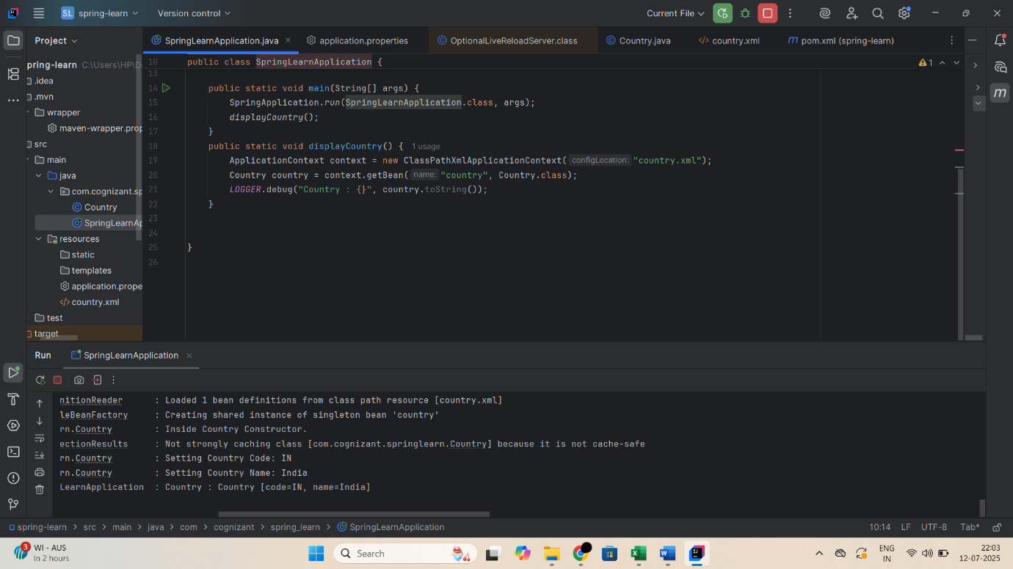

**3.Hello World RESTful Web Service**

**HelloController.java**

package com.cognizant.spring_learn.controller;

import org.slf4j.Logger;

import org.slf4j.LoggerFactory;

import org.springframework.web.bind.annotation.GetMapping;

import org.springframework.web.bind.annotation.RestController;

@RestController

public class HelloController {

private static final Logger LOGGER = LoggerFactory.getLogger(HelloController.class);

@GetMapping("/hello")

public String sayHello() {

LOGGER.info("START - sayHello()");

LOGGER.info("END - sayHello()");

return "Hello World!!";

}

}

**OUTPUT:**

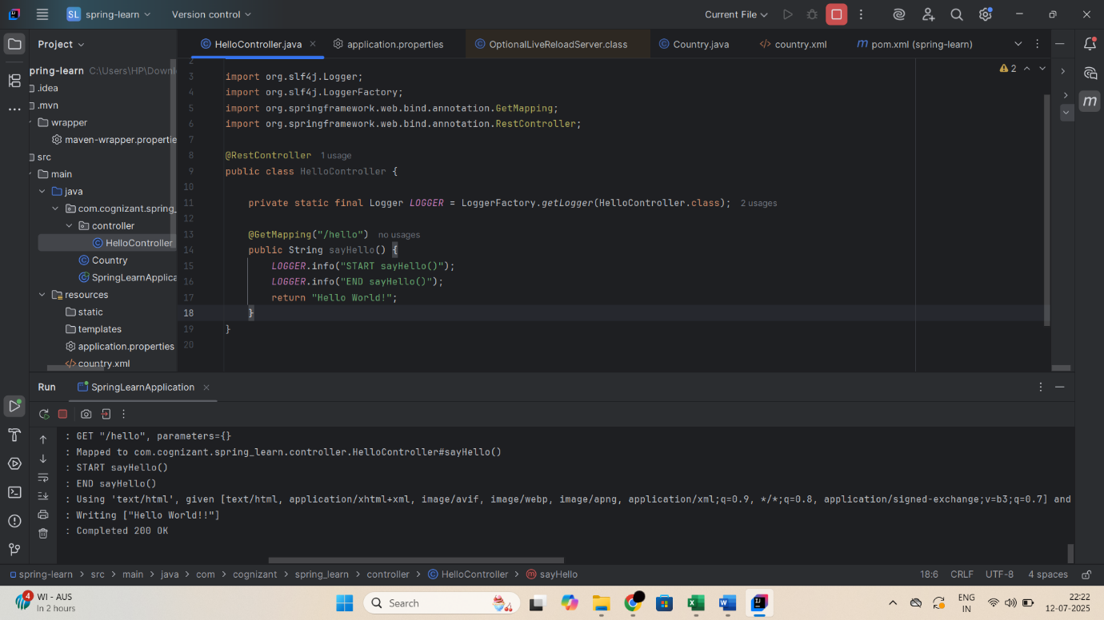

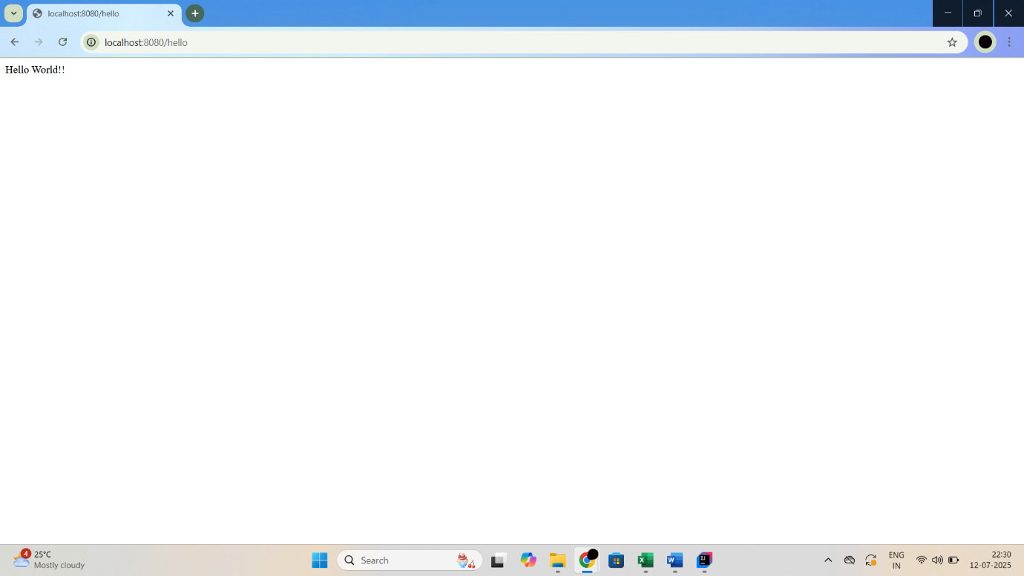

**4.REST - Country Web Service**

**CountryController.java**

package com.cognizant.spring_learn.controller;

import com.cognizant.spring_learn.Country;

import org.springframework.web.bind.annotation.RequestMapping;

import org.springframework.web.bind.annotation.RestController;

import org.springframework.context.ApplicationContext;

import org.springframework.context.support.ClassPathXmlApplicationContext;

@RestController

public class CountryController {

@RequestMapping("/country")

public Country getCountryIndia() {

ApplicationContext context = new ClassPathXmlApplicationContext("country.xml");

Country country = context.getBean("country", Country.class);

return country;

}

}

**OUTPUT:**

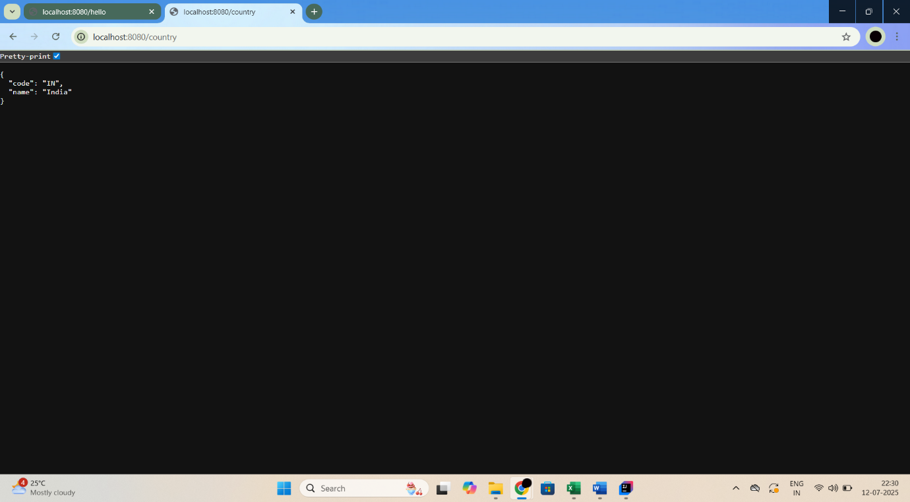

**5.REST - Get country based on country code**

**CountryController.java**

package com.cognizant.spring_learn.controller;

import com.cognizant.spring_learn.Country;

import com.cognizant.spring_learn.service.CountryService;

import org.springframework.beans.factory.annotation.Autowired;

import org.springframework.web.bind.annotation.*;

@RestController

public class CountryController {

@Autowired

private CountryService countryService;

@GetMapping("/countries/{code}")

public Country getCountry(@PathVariable String code) {

return countryService.getCountry(code);

}

}

**CountryService.java**

package com.cognizant.spring_learn.service;

import com.cognizant.spring_learn.Country;

import org.springframework.context.ApplicationContext;

import org.springframework.context.support.ClassPathXmlApplicationContext;

import org.springframework.stereotype.Service;

import java.util.List;

@Service

public class CountryService {

public Country getCountry(String code) {

ApplicationContext context = new ClassPathXmlApplicationContext("country.xml");

List<Country> countryList = context.getBean("countryList", List.class);

return countryList.stream()

.filter(c -> c.getCode().equalsIgnoreCase(code))

.findFirst()

.orElse(null);

}

}

**country.xml**

<?xml version="1.0" encoding="UTF-8"?>

<beans xmlns="http://www.springframework.org/schema/beans"

xmlns:xsi="http://www.w3.org/2001/XMLSchema-instance"

xsi:schemaLocation="

http://www.springframework.org/schema/beans

http://www.springframework.org/schema/beans/spring-beans.xsd">

<bean id="country" class="com.cognizant.springlearn.Country">

<property name="code" value="IN"/>

<property name="name" value="India"/>

</bean>

<bean id="countryList" class="java.util.ArrayList">

<constructor-arg>

<list>

<bean class="com.cognizant.springlearn.Country">

<property name="code" value="IN"/>

<property name="name" value="India"/>

</bean>

<bean class="com.cognizant.springlearn.Country">

<property name="code" value="US"/>

<property name="name" value="United States"/>

</bean>

<bean class="com.cognizant.springlearn.Country">

<property name="code" value="CN"/>

<property name="name" value="China"/>

</bean>

</list>

</constructor-arg>

</bean>

</beans>

**OUTPUT:**

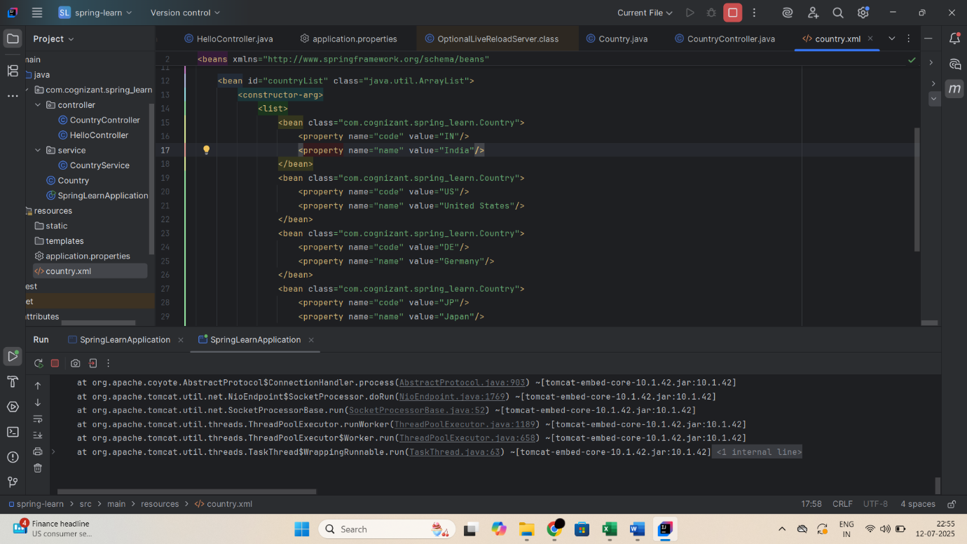

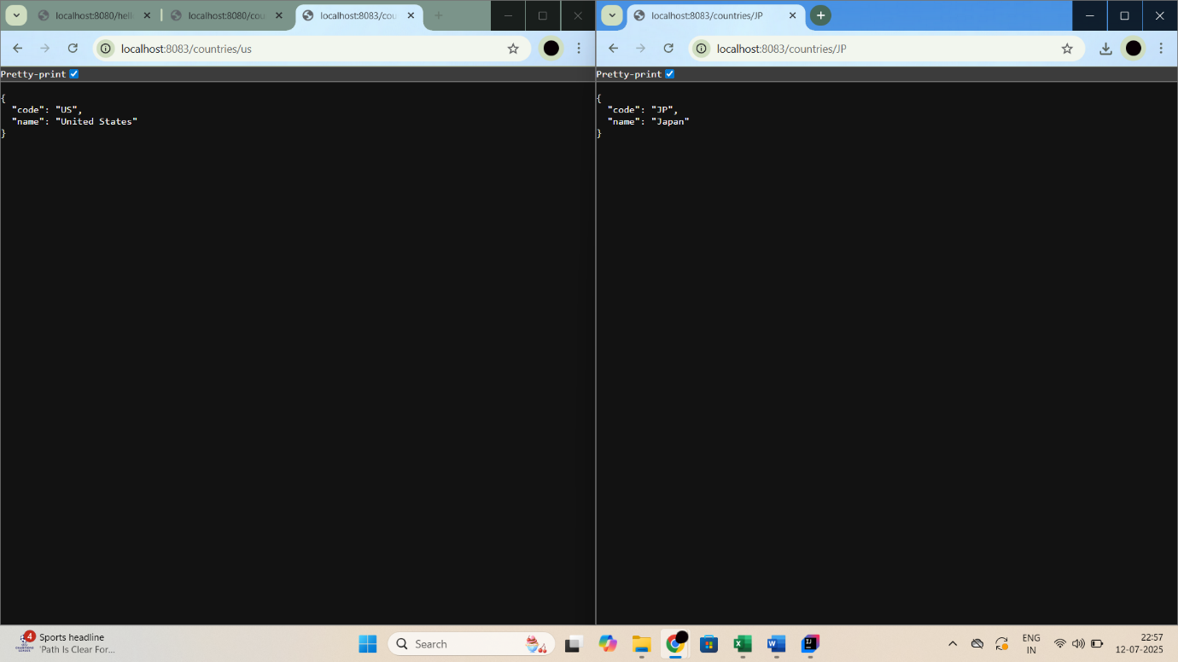

**6.Create authentication service that returns JWT**

AuthenticationController:

package com.cognizant.spring_learn.controller;

import jakarta.servlet.http.HttpServletRequest;

import org.springframework.web.bind.annotation.GetMapping;

import org.springframework.web.bind.annotation.RestController;

import io.jsonwebtoken.Jwts;

import io.jsonwebtoken.SignatureAlgorithm;

import java.util.Base64;

import java.util.Date;

import java.util.HashMap;

import java.util.Map;

@RestController

public class AuthenticationController {

private static final String SECRET_KEY = "mysecretkey";

@GetMapping("/authenticate")

public Map<String, String> authenticate(HttpServletRequest request) {

String authHeader = request.getHeader("Authorization");

String base64Credentials = authHeader.substring("Basic".length()).trim();

byte[] credDecoded = Base64.getDecoder().decode(base64Credentials);

String credentials = new String(credDecoded);

String[] values = credentials.split(":", 2);

String username = values[0];

String password = values[1];

String token = Jwts.builder()

.setSubject(username)

.setIssuedAt(new Date())

.setExpiration(new Date(System.currentTimeMillis() + 1000 * 60 * 60))

.signWith(SignatureAlgorithm.HS256, SECRET_KEY)

.compact();

Map<String, String> response = new HashMap<>();

response.put("token", token);

return response;

}

}

SecurityConfig:

package com.cognizant.spring_learn.config;

import org.springframework.context.annotation.Bean;

import org.springframework.context.annotation.Configuration;

import org.springframework.security.config.annotation.web.builders.HttpSecurity;

import org.springframework.security.web.SecurityFilterChain;

@Configuration

public class SecurityConfig {

@Bean

public SecurityFilterChain filterChain(HttpSecurity http) throws Exception {

http

.csrf().disable()

.authorizeRequests()

.antMatchers("/authenticate").permitAll()

.anyRequest().authenticated()

.and()

.httpBasic();

return http.build();

}

}

**OUTPUT:**

